ITA0601 – MACHINE LEARNING
LAB EXPERIMENTS
EXP-19: Naive Bayes classification for Bank Loan prediction
Dataset 1
Age | Income (₹) | Loan Amount (₹) | Credit Score | Loan Term (Years) | Loan Status
25 | 30000 | 100000 | 650 | 5 | Rejected
30 | 45000 | 150000 | 700 | 5 | Approved
35 | 60000 | 200000 | 750 | 10 | Approved
40 | 70000 | 250000 | 780 | 10 | Approved
28 | 35000 | 180000 | 620 | 5 | Rejected
45 | 80000 | 300000 | 800 | 15 | Approved
32 | 40000 | 220000 | 640 | 10 | Rejected
38 | 65000 | 180000 | 760 | 10 | Approved
27 | 32000 | 120000 | 610 | 5 | Rejected
50 | 90000 | 350000 | 820 | 15 | Approved

Python Code:
import pandas as pd
from sklearn.model_selection import train_test_split
from sklearn.naive_bayes import GaussianNB
from sklearn.metrics import accuracy_score
data = {
"Age": [25, 30, 35, 40, 28, 45, 32, 38, 27, 50],
"Income": [30000, 45000, 60000, 70000, 35000,
80000, 40000, 65000, 32000, 90000],
"Loan_Amount": [100000, 150000, 200000, 250000, 180000,
300000, 220000, 180000, 120000, 350000],
"Credit_Score": [650, 700, 750, 780, 620,
800, 640, 760, 610, 820],
"Loan_Term": [5, 5, 10, 10, 5, 15, 10, 10, 5, 15],
"Loan_Status": [
"Rejected", "Approved", "Approved", "Approved",
"Rejected", "Approved", "Rejected", "Approved",
"Rejected", "Approved"
]
}
df = pd.DataFrame(data)
df["Loan_Status"] = df["Loan_Status"].map({
"Rejected": 0,
"Approved": 1
})
X = df[["Age", "Income", "Loan_Amount",
"Credit_Score", "Loan_Term"]]
y = df["Loan_Status"]
X_train, X_test, y_train, y_test = train_test_split(
X, y, test_size=0.3, random_state=42
)
model = GaussianNB()
model.fit(X_train, y_train)
y_pred = model.predict(X_test)
print("Dataset 1 - Naive Bayes Classification")
print("Accuracy:",
round(accuracy_score(y_test, y_pred) * 100, 2), "%")
new_applicant = pd.DataFrame({
"Age": [35],
"Income": [60000],
"Loan_Amount": [200000],
"Credit_Score": [750],
"Loan_Term": [10]
})
prediction = model.predict(new_applicant)
if prediction[0] == 1:
print("Predicted Loan Status: Approved")
else:
print("Predicted Loan Status: Rejected")
Output:
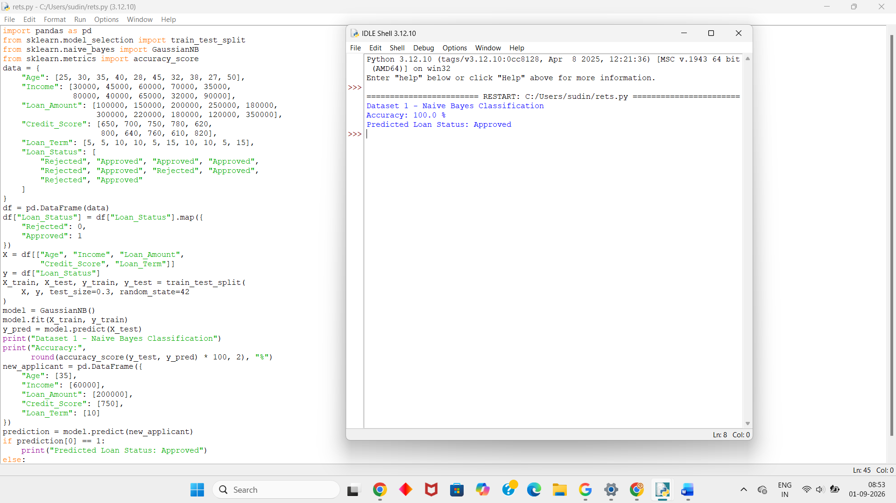
Dataset 2
Age | Income (₹) | Loan Amount (₹) | Credit Score | Loan Term (Years) | Loan Status
24 | 28000 | 90000 | 600 | 5 | Rejected
29 | 42000 | 140000 | 690 | 5 | Approved
34 | 55000 | 190000 | 730 | 10 | Approved
41 | 72000 | 280000 | 790 | 15 | Approved
26 | 30000 | 130000 | 610 | 5 | Rejected
46 | 85000 | 320000 | 810 | 15 | Approved
31 | 38000 | 170000 | 630 | 10 | Rejected
39 | 68000 | 210000 | 770 | 10 | Approved
27 | 33000 | 110000 | 620 | 5 | Rejected
52 | 95000 | 400000 | 830 | 20 | Approved
Python Code:
import pandas as pd
from sklearn.model_selection import train_test_split
from sklearn.naive_bayes import GaussianNB
from sklearn.metrics import accuracy_score
data = {
"Age": [24, 29, 34, 41, 26, 46, 31, 39, 27, 52],
"Income": [28000, 42000, 55000, 72000, 30000,
85000, 38000, 68000, 33000, 95000],
"Loan_Amount": [90000, 140000, 190000, 280000, 130000,
320000, 170000, 210000, 110000, 400000],
"Credit_Score": [600, 690, 730, 790, 610,
810, 630, 770, 620, 830],
"Loan_Term": [5, 5, 10, 15, 5, 15, 10, 10, 5, 20],
"Loan_Status": [
"Rejected", "Approved", "Approved", "Approved",
"Rejected", "Approved", "Rejected", "Approved",
"Rejected", "Approved"
]
}
df = pd.DataFrame(data)
df["Loan_Status"] = df["Loan_Status"].map({
"Rejected": 0,
"Approved": 1
})
X = df[["Age", "Income", "Loan_Amount",
"Credit_Score", "Loan_Term"]]
y = df["Loan_Status"]
X_train, X_test, y_train, y_test = train_test_split(
X, y, test_size=0.3, random_state=42
)
model = GaussianNB()
model.fit(X_train, y_train)
y_pred = model.predict(X_test)
print("Dataset 2 - Naive Bayes Classification")
print("Accuracy:",
round(accuracy_score(y_test, y_pred) * 100, 2), "%")
new_applicant = pd.DataFrame({
"Age": [34],
"Income": [55000],
"Loan_Amount": [190000],
"Credit_Score": [730],
"Loan_Term": [10]
})
prediction = model.predict(new_applicant)
if prediction[0] == 1:
print("Predicted Loan Status: Approved")
else:
print("Predicted Loan Status: Rejected")
Output:
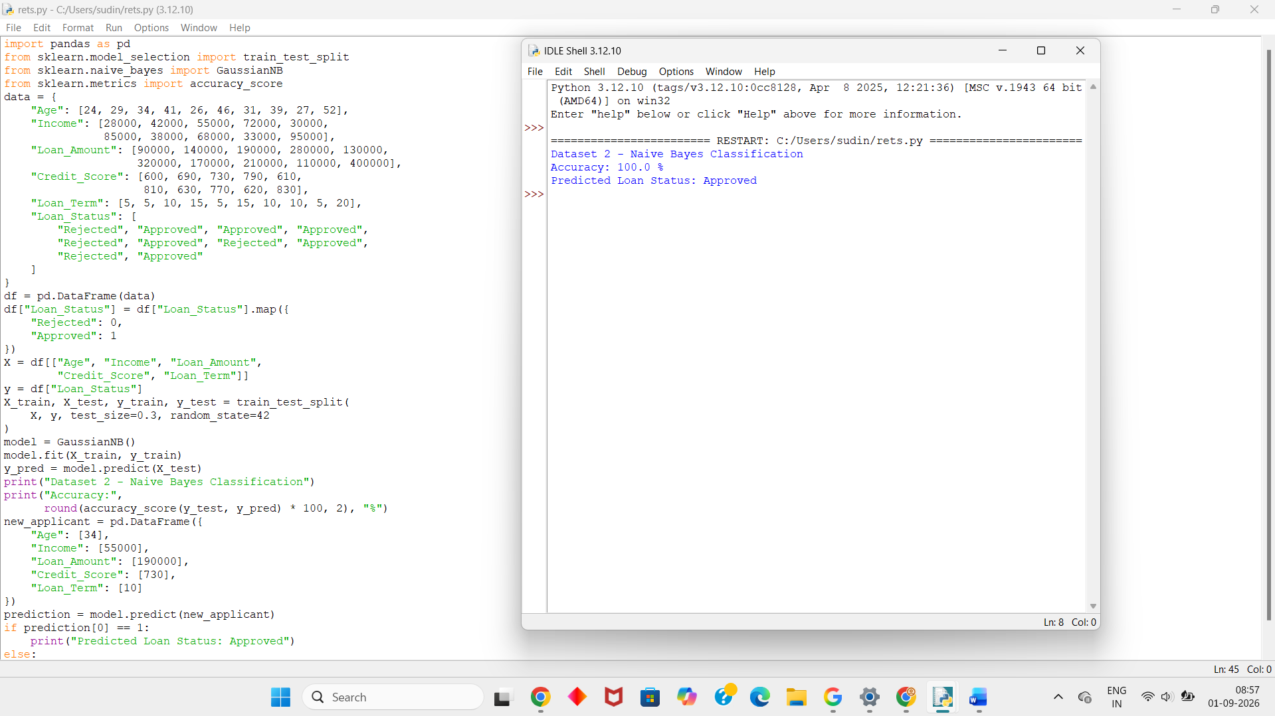
Dataset 3
Age | Income (₹) | Loan Amount (₹) | Credit Score | Loan Term (Years) | Loan Status
23 | 25000 | 80000 | 590 | 5 | Rejected
31 | 48000 | 160000 | 710 | 10 | Approved
36 | 58000 | 200000 | 740 | 10 | Approved
42 | 75000 | 270000 | 790 | 15 | Approved
29 | 34000 | 150000 | 630 | 5 | Rejected
48 | 88000 | 330000 | 820 | 20 | Approved
33 | 39000 | 180000 | 640 | 10 | Rejected
37 | 62000 | 190000 | 755 | 10 | Approved
26 | 31000 | 100000 | 605 | 5 | Rejected
55 | 100000 | 450000 | 840 | 20 | Approved
Python Code:
import pandas as pd
from sklearn.model_selection import train_test_split
from sklearn.naive_bayes import GaussianNB
from sklearn.metrics import accuracy_score
data = {
"Age": [23, 31, 36, 42, 29, 48, 33, 37, 26, 55],
"Income": [25000, 48000, 58000, 75000, 34000,
88000, 39000, 62000, 31000, 100000],
"Loan_Amount": [80000, 160000, 200000, 270000, 150000,
330000, 180000, 190000, 100000, 450000],
"Credit_Score": [590, 710, 740, 790, 630,
820, 640, 755, 605, 840],
"Loan_Term": [5, 10, 10, 15, 5, 20, 10, 10, 5, 20],
"Loan_Status": [
"Rejected", "Approved", "Approved", "Approved",
"Rejected", "Approved", "Rejected", "Approved",
"Rejected", "Approved"
]
}
df = pd.DataFrame(data)
df["Loan_Status"] = df["Loan_Status"].map({
"Rejected": 0,
"Approved": 1
})
X = df[["Age", "Income", "Loan_Amount",
"Credit_Score", "Loan_Term"]]
y = df["Loan_Status"]
X_train, X_test, y_train, y_test = train_test_split(
X, y, test_size=0.3, random_state=42
)
model = GaussianNB()
model.fit(X_train, y_train)
y_pred = model.predict(X_test)
print("Dataset 3 - Naive Bayes Classification")
print("Accuracy:",
round(accuracy_score(y_test, y_pred) * 100, 2), "%")
new_applicant = pd.DataFrame({
"Age": [42],
"Income": [75000],
"Loan_Amount": [270000],
"Credit_Score": [790],
"Loan_Term": [15]
})
prediction = model.predict(new_applicant)
if prediction[0] == 1:
print("Predicted Loan Status: Approved")
else:
print("Predicted Loan Status: Rejected")
Output:
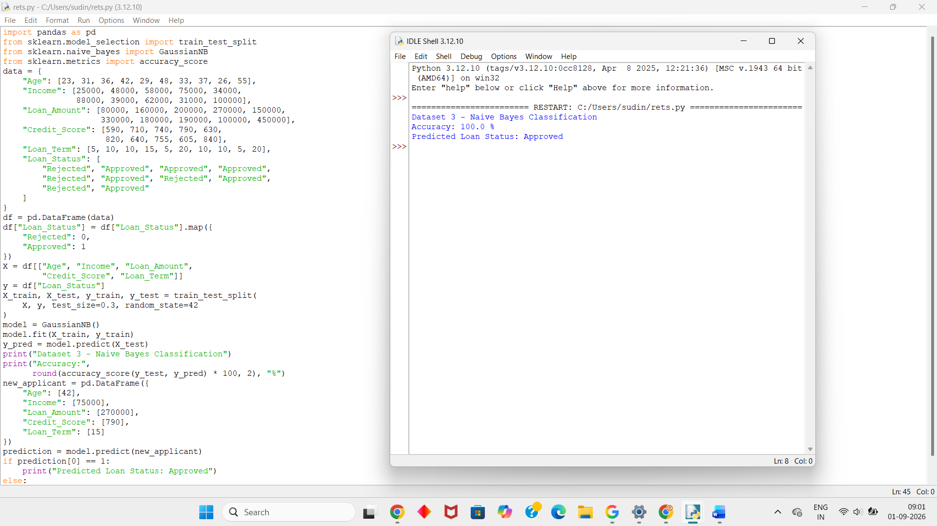
Dataset 4
Age | Income (₹) | Loan Amount (₹) | Credit Score | Loan Term (Years) | Loan Status
22 | 26000 | 70000 | 580 | 5 | Rejected
28 | 40000 | 130000 | 680 | 5 | Approved
35 | 57000 | 210000 | 750 | 10 | Approved
43 | 76000 | 290000 | 800 | 15 | Approved
30 | 36000 | 160000 | 625 | 10 | Rejected
47 | 82000 | 310000 | 815 | 15 | Approved
32 | 41000 | 190000 | 645 | 10 | Rejected
40 | 69000 | 230000 | 765 | 10 | Approved
25 | 29000 | 95000 | 600 | 5 | Rejected
54 | 98000 | 420000 | 835 | 20 | Approved
Python Code:
import pandas as pd
from sklearn.model_selection import train_test_split
from sklearn.naive_bayes import GaussianNB
from sklearn.metrics import accuracy_score
data = {
"Age": [22, 28, 35, 43, 30, 47, 32, 40, 25, 54],
"Income": [26000, 40000, 57000, 76000, 36000,
82000, 41000, 69000, 29000, 98000],
"Loan_Amount": [70000, 130000, 210000, 290000, 160000,
310000, 190000, 230000, 95000, 420000],
"Credit_Score": [580, 680, 750, 800, 625,
815, 645, 765, 600, 835],
"Loan_Term": [5, 5, 10, 15, 10, 15, 10, 10, 5, 20],
"Loan_Status": [
"Rejected", "Approved", "Approved", "Approved",
"Rejected", "Approved", "Rejected", "Approved",
"Rejected", "Approved"
]
}
df = pd.DataFrame(data)
df["Loan_Status"] = df["Loan_Status"].map({
"Rejected": 0,
"Approved": 1
})
X = df[["Age", "Income", "Loan_Amount",
"Credit_Score", "Loan_Term"]]
y = df["Loan_Status"]
X_train, X_test, y_train, y_test = train_test_split(
X, y, test_size=0.3, random_state=42
)
model = GaussianNB()
model.fit(X_train, y_train)
y_pred = model.predict(X_test)
print("Dataset 4 - Naive Bayes Classification")
print("Accuracy:",
round(accuracy_score(y_test, y_pred) * 100, 2), "%")
new_applicant = pd.DataFrame({
"Age": [43],
"Income": [76000],
"Loan_Amount": [290000],
"Credit_Score": [800],
"Loan_Term": [15]
})
prediction = model.predict(new_applicant)
if prediction[0] == 1:
print("Predicted Loan Status: Approved")
else:
print("Predicted Loan Status: Rejected")
Output:
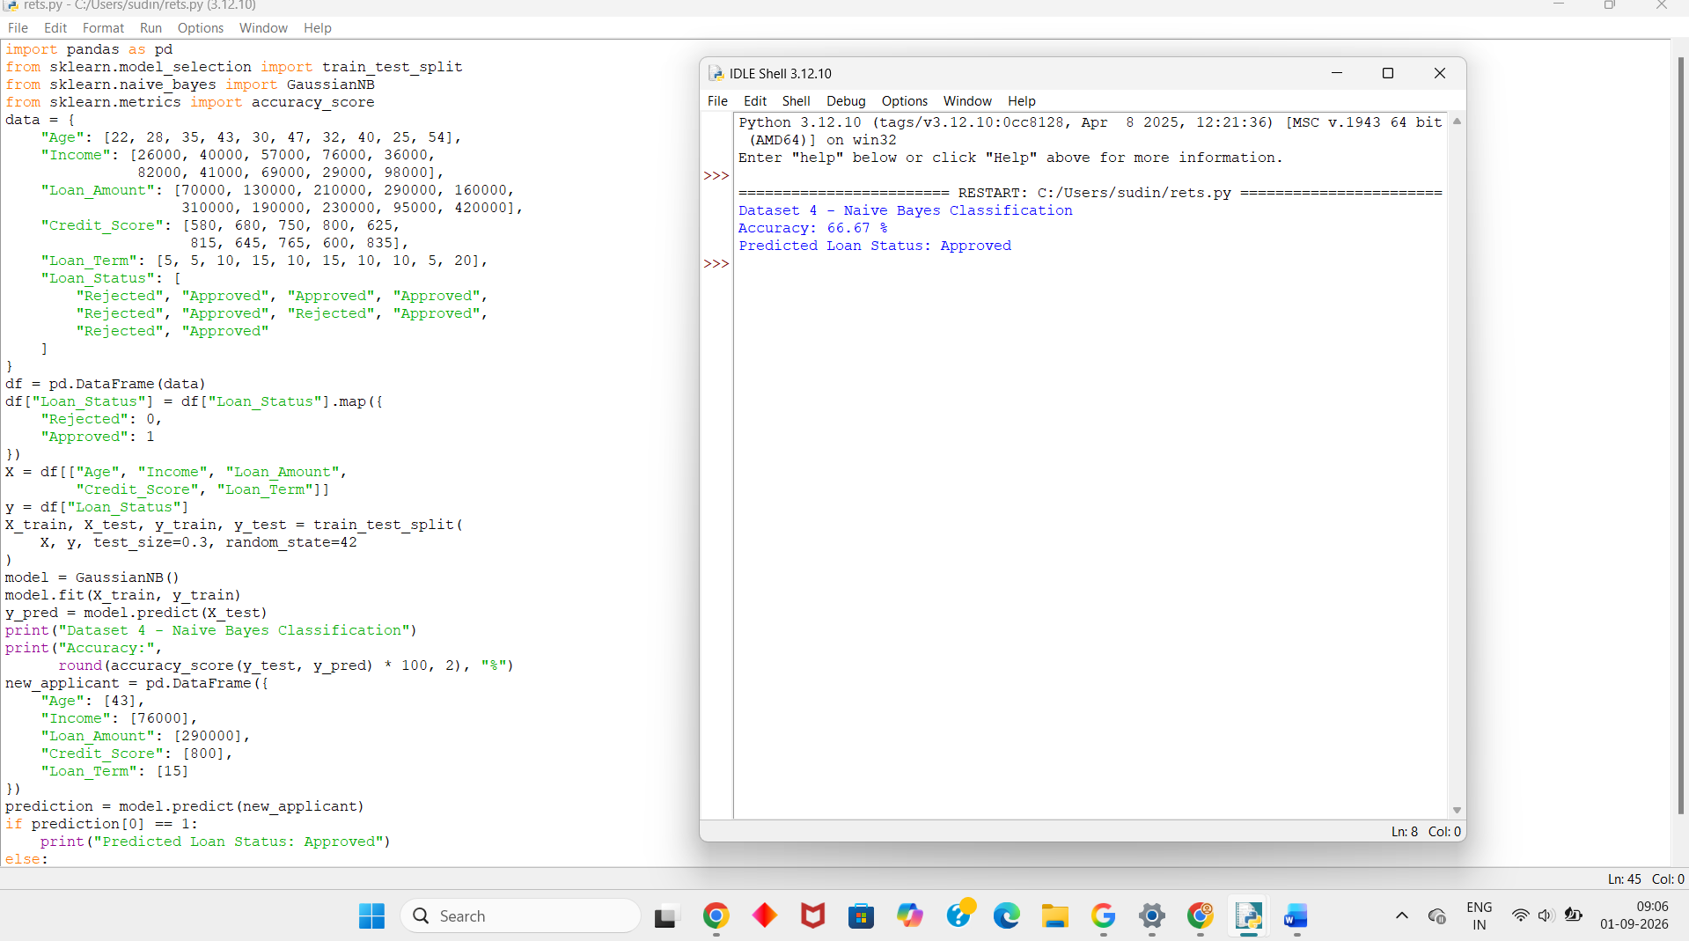

Dataset 5
Age | Income (₹) | Loan Amount (₹) | Credit Score | Loan Term (Years) | Loan Status
21 | 24000 | 60000 | 570 | 5 | Rejected
30 | 43000 | 145000 | 695 | 5 | Approved
37 | 61000 | 220000 | 760 | 10 | Approved
44 | 78000 | 300000 | 805 | 15 | Approved
27 | 31000 | 125000 | 615 | 5 | Rejected
49 | 90000 | 350000 | 825 | 20 | Approved
34 | 37000 | 175000 | 635 | 10 | Rejected
41 | 67000 | 215000 | 775 | 10 | Approved
26 | 28000 | 90000 | 595 | 5 | Rejected
56 | 105000 | 460000 | 845 | 20 | Approved
Python Code:
import pandas as pd
from sklearn.model_selection import train_test_split
from sklearn.naive_bayes import GaussianNB
from sklearn.metrics import accuracy_score
data = {
"Age": [21, 30, 37, 44, 27, 49, 34, 41, 26, 56],
"Income": [24000, 43000, 61000, 78000, 31000,
90000, 37000, 67000, 28000, 105000],
"Loan_Amount": [60000, 145000, 220000, 300000, 125000,
350000, 175000, 215000, 90000, 460000],
"Credit_Score": [570, 695, 760, 805, 615,
825, 635, 775, 595, 845],
"Loan_Term": [5, 5, 10, 15, 5, 20, 10, 10, 5, 20],
"Loan_Status": [
"Rejected", "Approved", "Approved", "Approved",
"Rejected", "Approved", "Rejected", "Approved",
"Rejected", "Approved"
]
}
df = pd.DataFrame(data)
df["Loan_Status"] = df["Loan_Status"].map({
"Rejected": 0,
"Approved": 1
})
X = df[["Age", "Income", "Loan_Amount",
"Credit_Score", "Loan_Term"]]
y = df["Loan_Status"]
X_train, X_test, y_train, y_test = train_test_split(
X, y, test_size=0.3, random_state=42
)
model = GaussianNB()
model.fit(X_train, y_train)
y_pred = model.predict(X_test)
print("Dataset 5 - Naive Bayes Classification")
print("Accuracy:",
round(accuracy_score(y_test, y_pred) * 100, 2), "%")
new_applicant = pd.DataFrame({
"Age": [49],
"Income": [90000],
"Loan_Amount": [350000],
"Credit_Score": [825],
"Loan_Term": [20]
})
prediction = model.predict(new_applicant)
if prediction[0] == 1:
print("Predicted Loan Status: Approved")
else:
print("Predicted Loan Status: Rejected")
Output:
